Simplification

# Bug Charge Checked Out Room

As, the purpose of this test is to simplify the reproduction of the bug using an automated test without any user input. The test is performed without any user input and all the methods call are automated. As there is no method that can be used to check the charge of the room without changing the code, the print output is taken as a confirmation of the bugs that has been reported.

The automated test done to replicate the bug that enable user to charge the room that has been checked out is demonstrated in the screenshots below. In figure 1, 2 and 3 the UAT test done to replicate the bug has been automated to show the same bug being generated. The figure 4 automate the generation of bug for 20 times using a loop to generate random variable that is been used as an input and all the test shows that the bug is present.

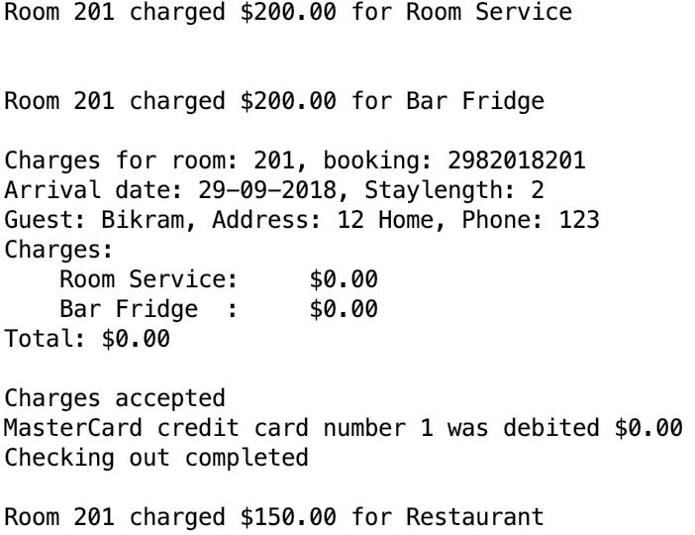

Figure 1 : Bug Charge Checked Out Room case 1.

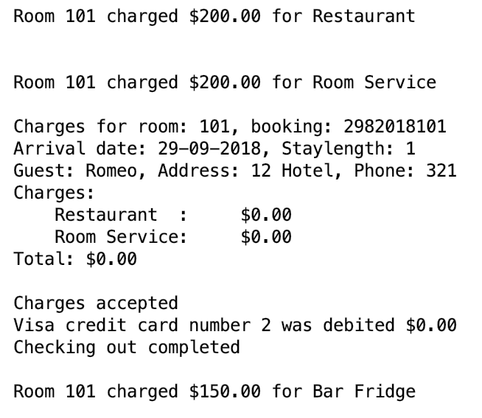

Figure 2 : Bug Charge Checked Out Room case 2.

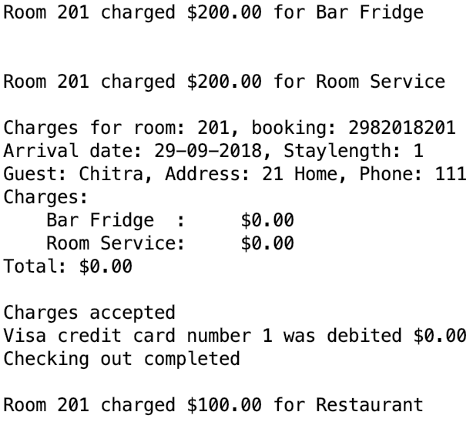

Figure 3 : Bug Charge Checked Out Room charge case 3.

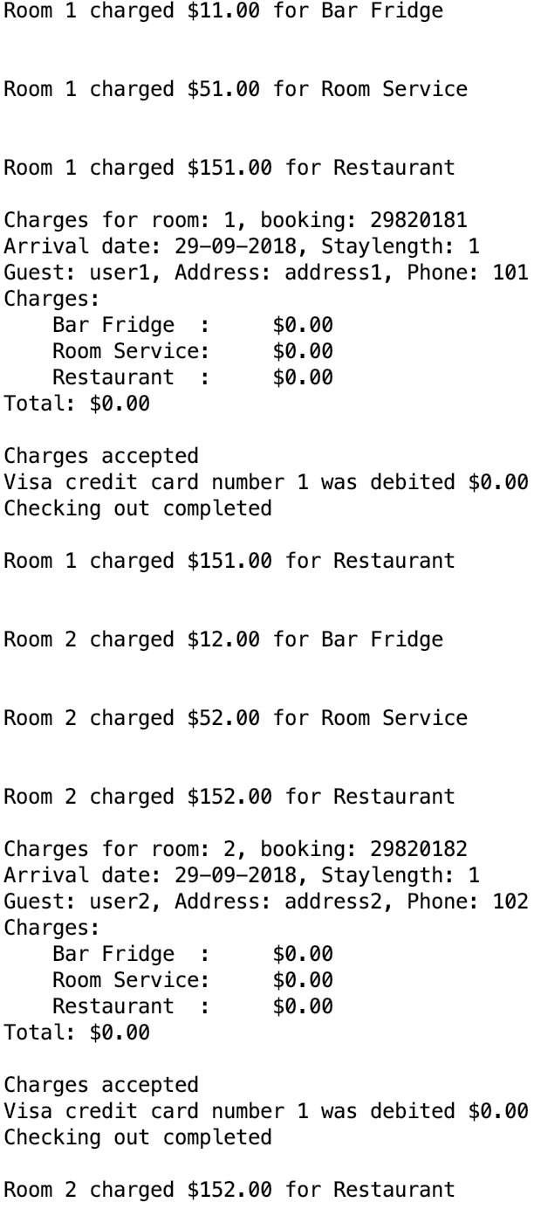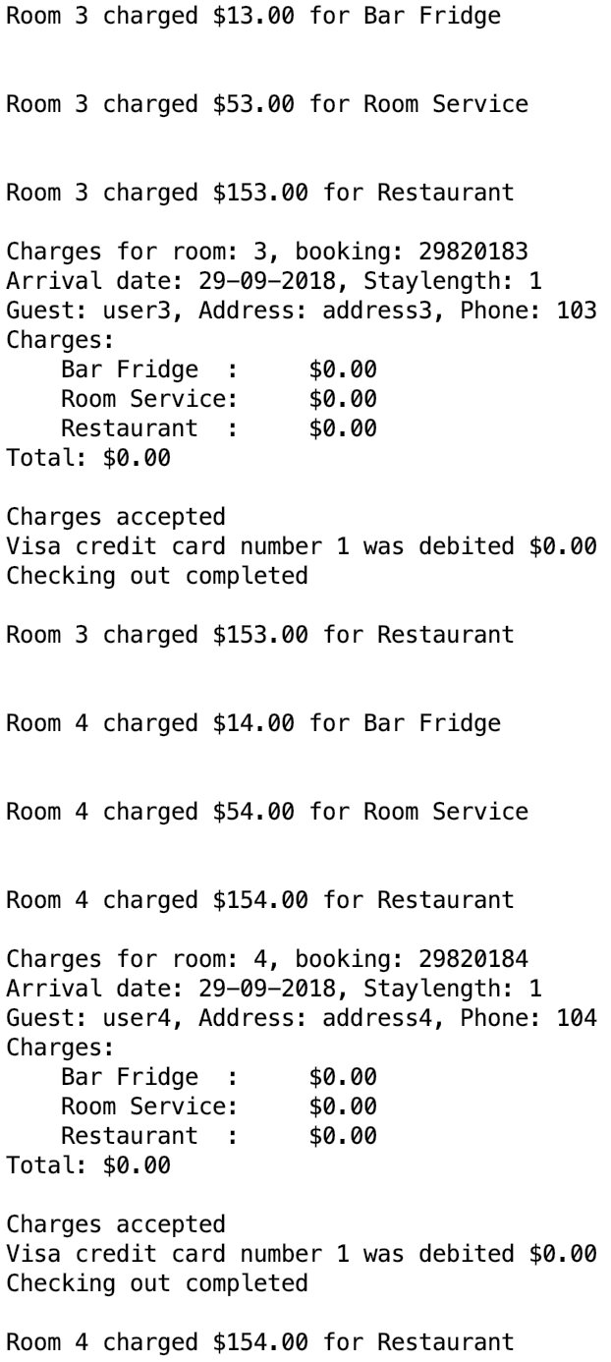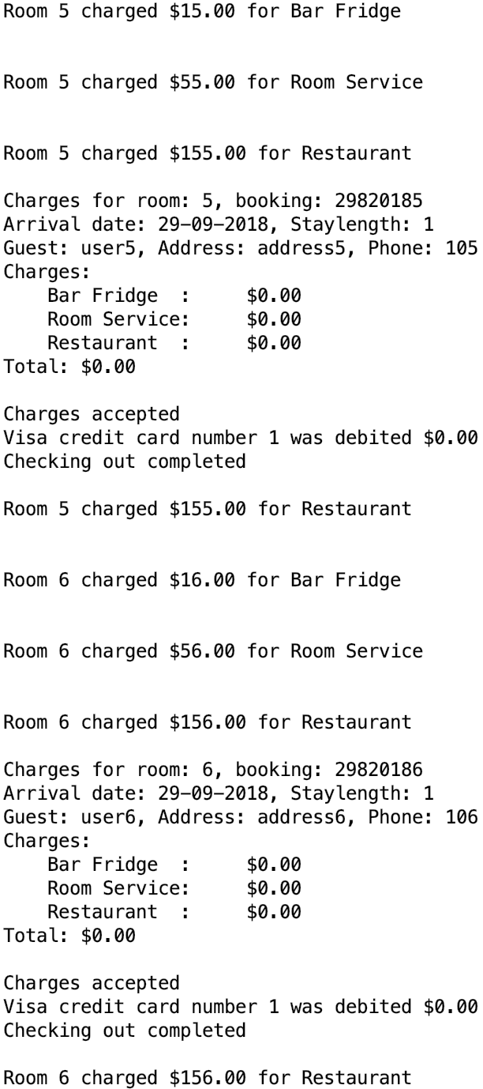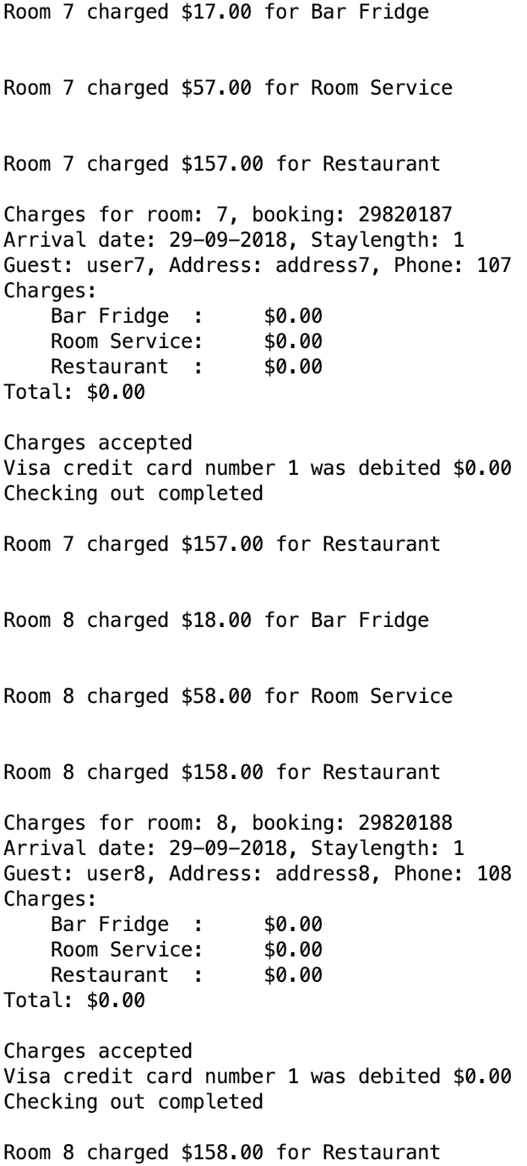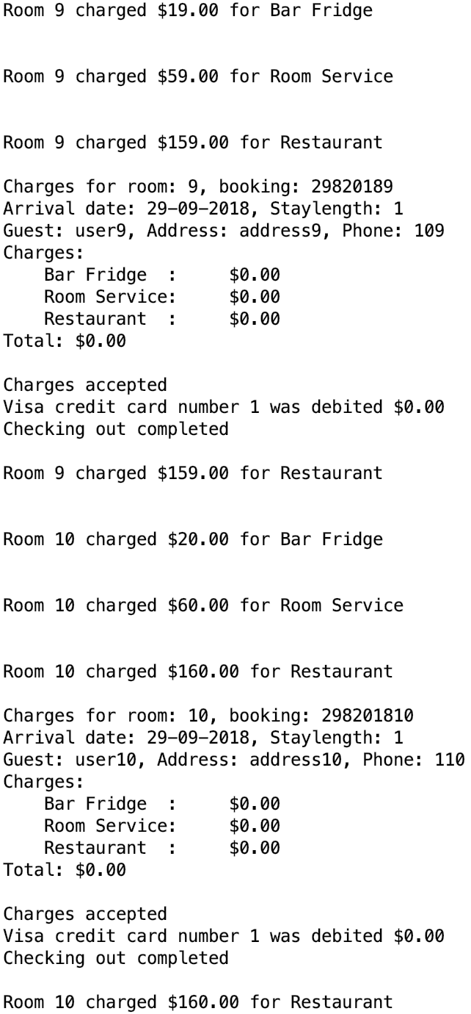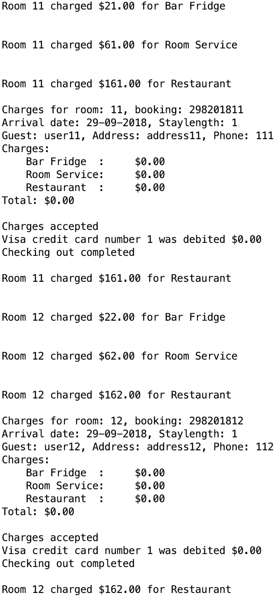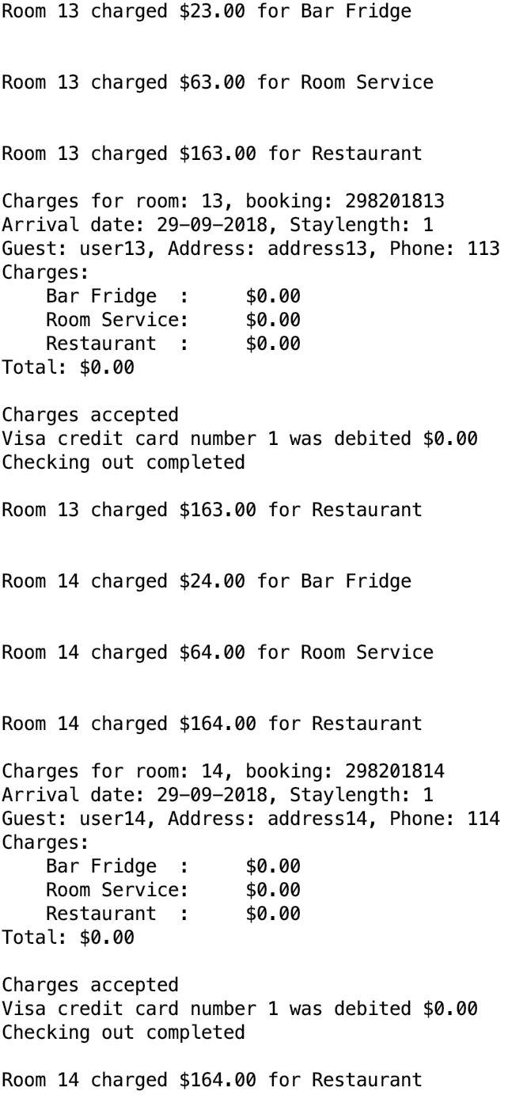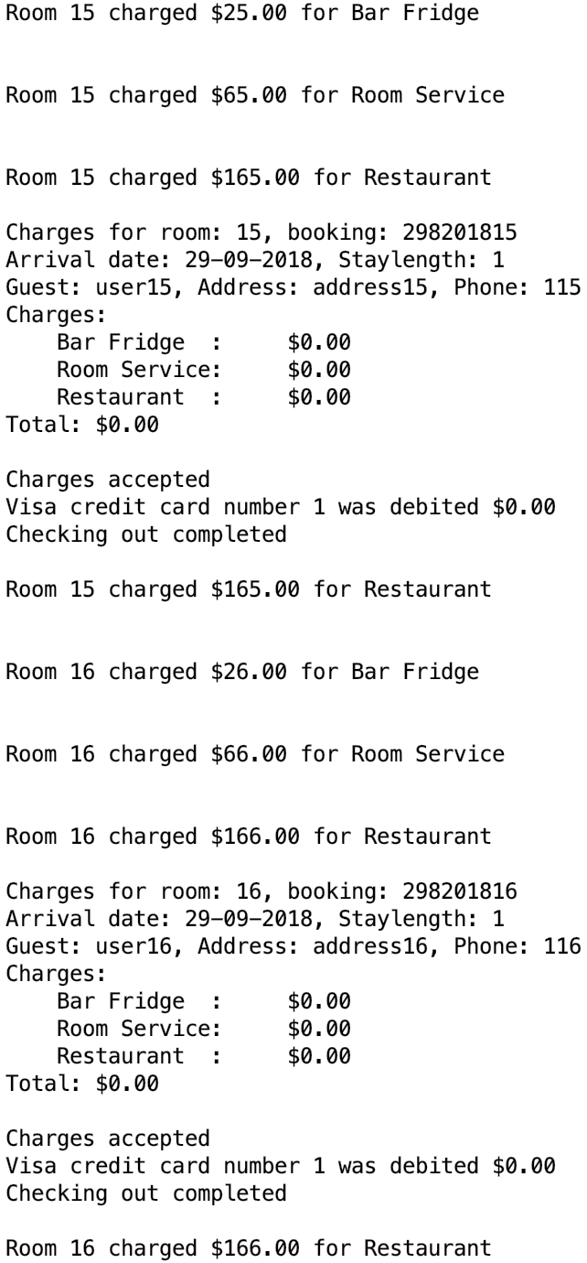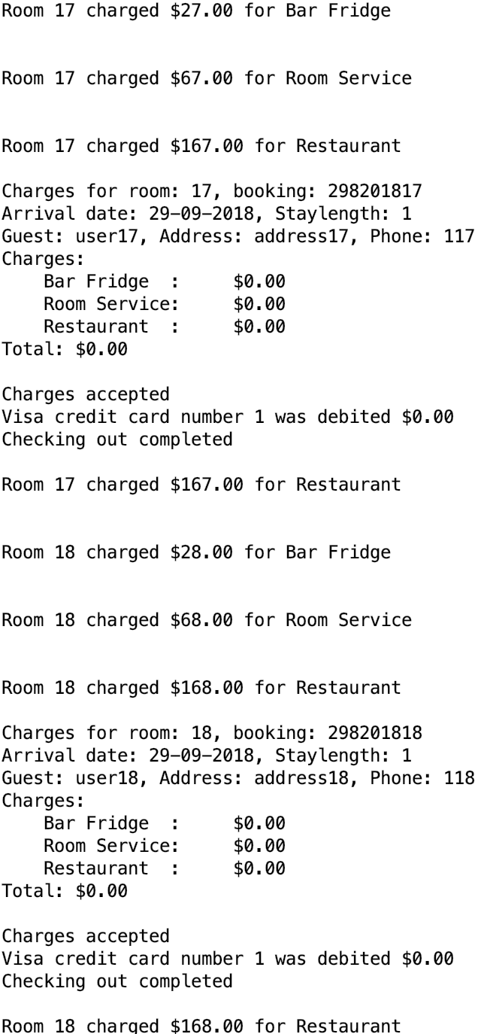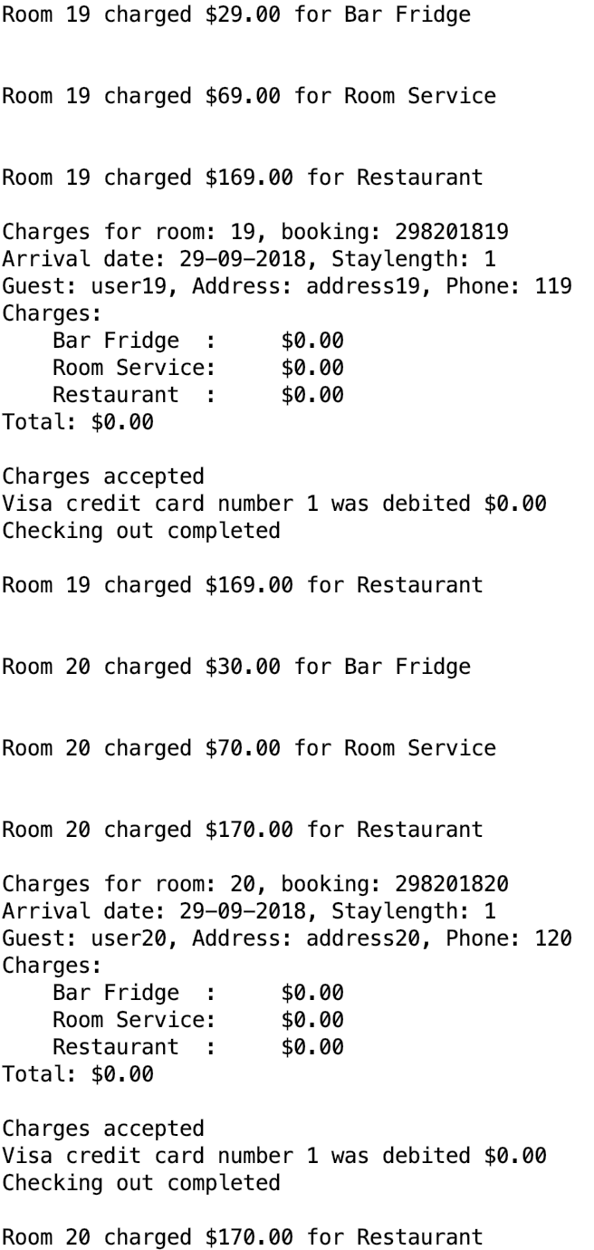

Figure 4: Bug Charge Checked Out Room case 4